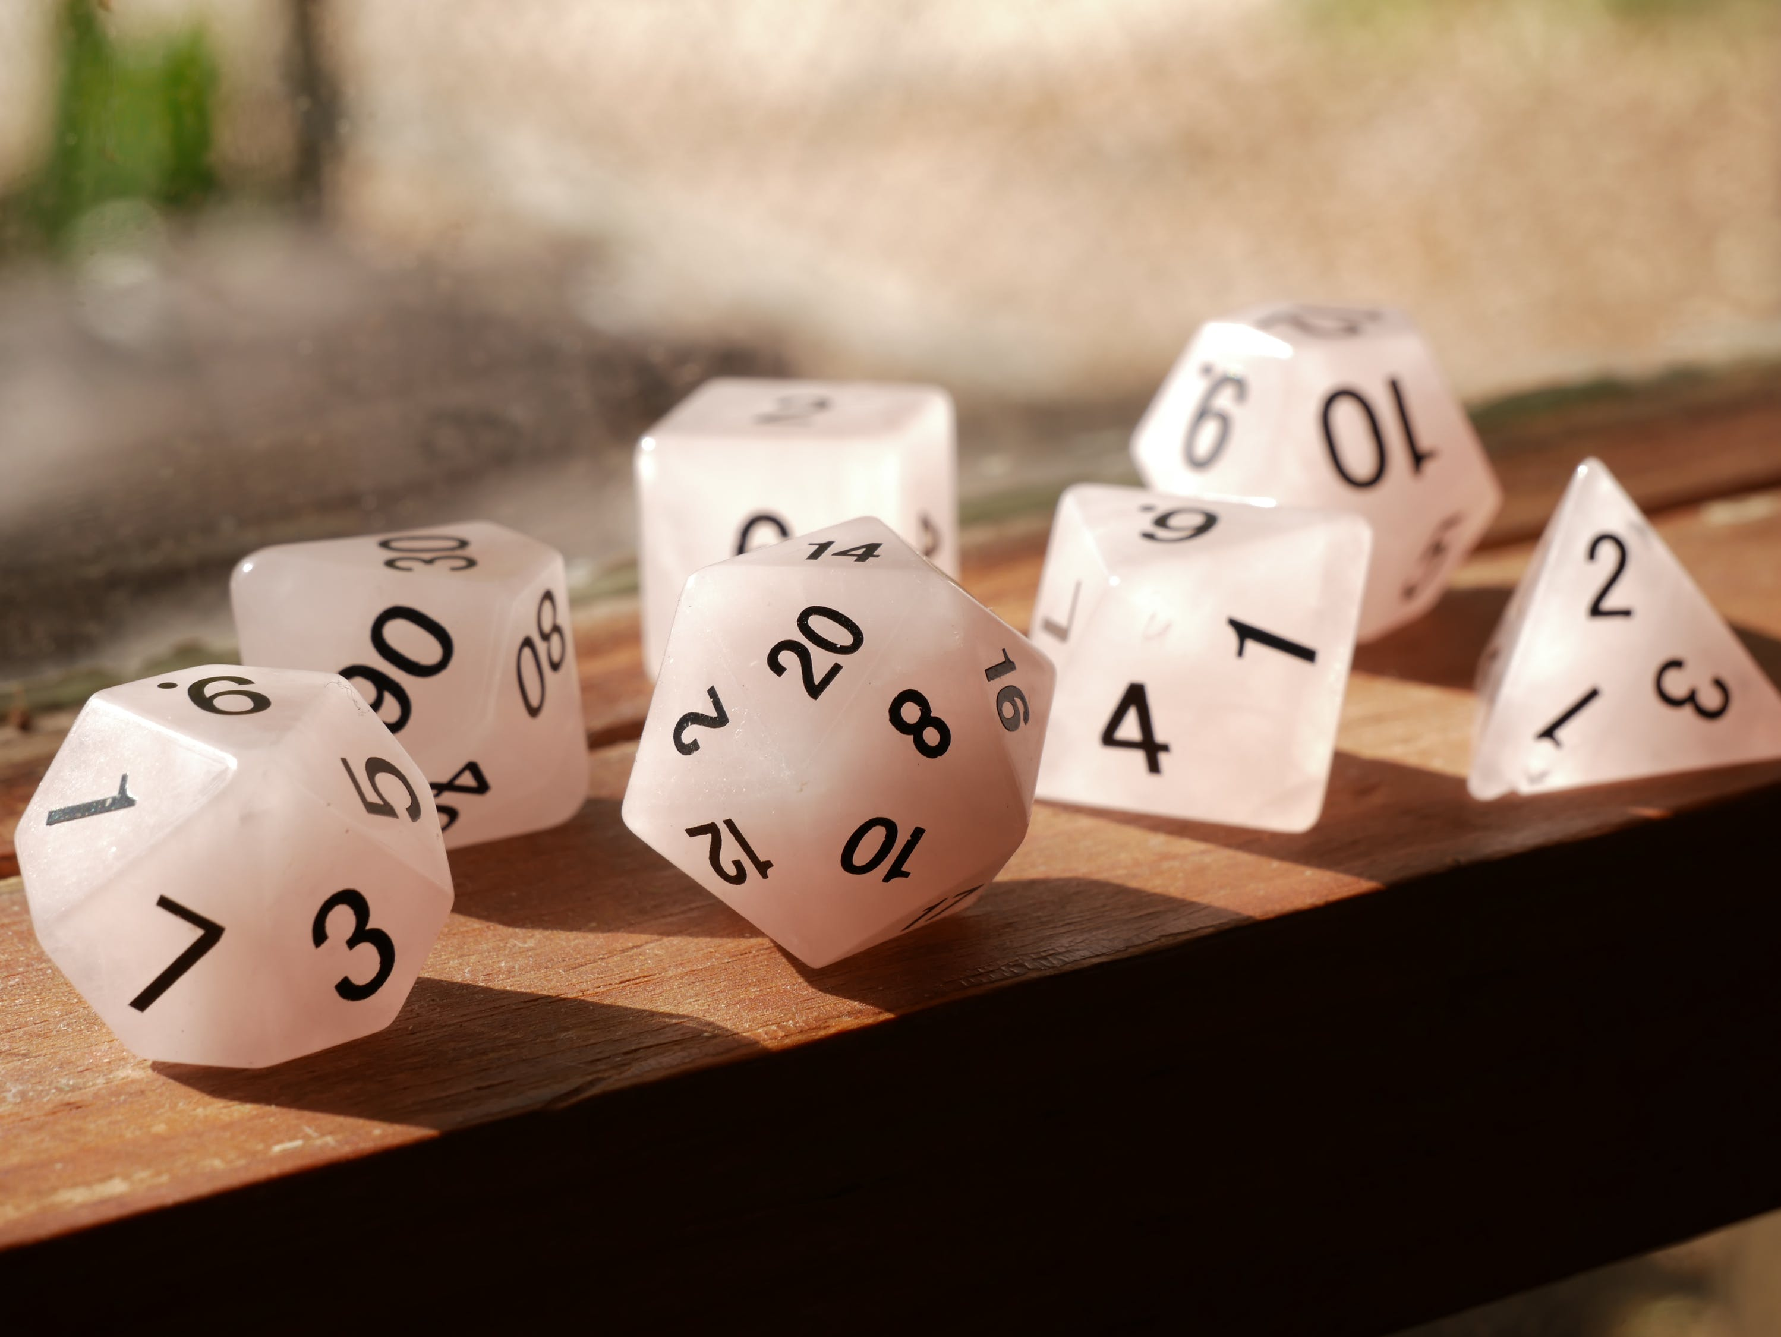

Scott Lucier

Dealing With The Aging Roll20 Virtual Tabletop Application

­­

TABLE OF CONTENTS

Introduction 3

VTT Features and Roll20 4

What VTT to Switch To? 5

Foundry 5

Astral 5

Fantasy Grounds 5

Example Screenshots 6

Conclusion 7

Key Takeaways 7

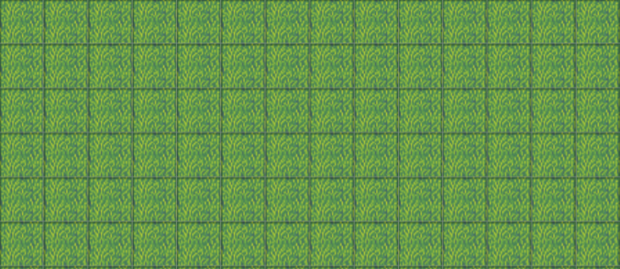

# Introduction

Roll20 is a virtual tabletop (VTT) web application launched in 2012. It allows users to run tabletop games such as Dungeons and Dragons, Call of Cthulhu, and Godbound using a computer. It’s used by casual and professional gamemasters alike, as well as their players, and has millions of such users. The application offers a free tier and two paid tiers. The free tier gets access to basic token and character sheet functionality, and the upper tiers get more storage space, dynamic lighting, and other features. The highest subscription tier gets API access, which allows users to atomate aspects of their games (such as ammunition tracking) with basic scripting[1]. Compendium packs can also be purchased that contain rules and/or content for various tabletop games.

Unfortunately, Roll20 is outdated and outcompeted in most aspects by newer software, and most users, casual and professional, should abandon the Roll20 platform for a different virtual tabletop, likely Foundry, although other options exist.

# VTT Features and roll20

What features do we want in a VTT? Well, at the basic level a map, tokens to move on the map, character sheets, and a way to roll dice. Every VTT can do this, so virtual tabletop applications compete on how easy it is to carry out basic operations (the quality of the user interface / visual performance), what additional frills are added, and of course, price.

Common VTT features include:

* Dynamic Lighting / Walls – A way of controlling what players can see and move to at a given time.
* Integration with popular game systems – Automatic monster import, preset maps, ways of avoiding spending time manually inputting content.
* Animations or other complex visual features – i.e. an animation of a fireball spell.
* Music and sound effects.
* Import / export of content between different campaigns
* Voice and video chat.
* Automation – scripts, resource tracking, ways to teleport tokens around the map, etc.

Roll20 does have all these features. It just implements many of them poorly. Dynamic Lighting is tedious to work with and lags the game, framerate and lag is a constant issue, the voice and video chat are finicky. Getting access to automation requires ten dollars a month, and while Roll20 does have a large array of supported game systems, the character sheets for them are mediocre at best. The user interface is an outdated mess. Even high tier paid users sometimes struggle to import maps, as there’s a restrictive 10MB image size upload limit. 10MB isn’t much.

While I don’t have access to internal Roll20 documents, this stagnation is probably because the development team is trying to incrementally improve of a years old system. While they are making some progress, the last major update was a change to the dynamic lighting system that made it only marginally better[2], and the platform had seen little improvement for years before that.

In short, Roll20 Is outdated and offers little to gamemasters and players, with the notable exception of the wide array of supported systems and integrated content.

# what vtt to switch to?

## [Foundry](https://foundryvtt.com/)

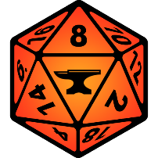

Foundry can be considered a direct upgrade to Roll20, and is best for users looking for a VTT with some power. It offers a large degree of customizability with a user created slot-in module system for content, UI, and other changes.

It’s locally hosted, and does require a decent computer to run. Whether this is an advantage or disadvantage is debatable, but users can be assured that the $50 price tag will be one time. Players join via web browser, at no charge. Web hosting is available at a cost.

Notable drawbacks include no free tier, a lower amount of supported game systems, and a lack of integrated content for those systems. Note however that at least in the case of DND 5e, user created modules offer import functionality, both of content from the Online sourcebook compendium DND Beyond, and even entire Roll20 campaigns.

## [Astral](https://www.astraltabletop.com/)



Astral is a near direct Roll20 clone, entirely web based.

It offers everything Roll20 does, minus some game systems and integrated content. The tutorial is quite nice as well.

Starting off in the free tier, it already gives more storage space for maps and tokens then Roll20, as well dynamic lighting, and a generally better experience with less lag. Parts to construct maps in Astral are also provided.

Higher tiers add more storage space, better map making materials, integrated voice and video chat, and other features for a comparable price to Roll20.

Notable drawbacks include a lack of integrated content, and less supported game systems. The later factor is somewhat mitigated by customable character sheets one could adapt to most game systems on their own.

## [Fantasy Grounds](https://www.fantasygrounds.com/home/home.php)

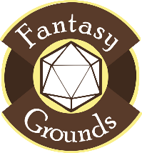

Fantasy Grounds does its own thing.

It supports only a handful of systems, but ramps of the automation factor on each of them. And ramps up the price. While in the long run it is cheaper than Roll20, $40 per player + gamemaster or $150 for just the gamemaster isn’t cheap. And to take advantage of the great automation requires buying sourcebooks for Fantasy Grounds specifically

From a user interface side and performance side, Fantasy Grounds is ok. Still older software, but runs well enough.

It’s strongest suit is it’s integrated content. Whole adventure modules can be purchased set up ready to run.

Notable Drawbacks: While the UI isn’t great, the largest drawback is price. You could easily spend hundreds or even thousands of dollars on Fantasy Grounds.

# Example Screenshots

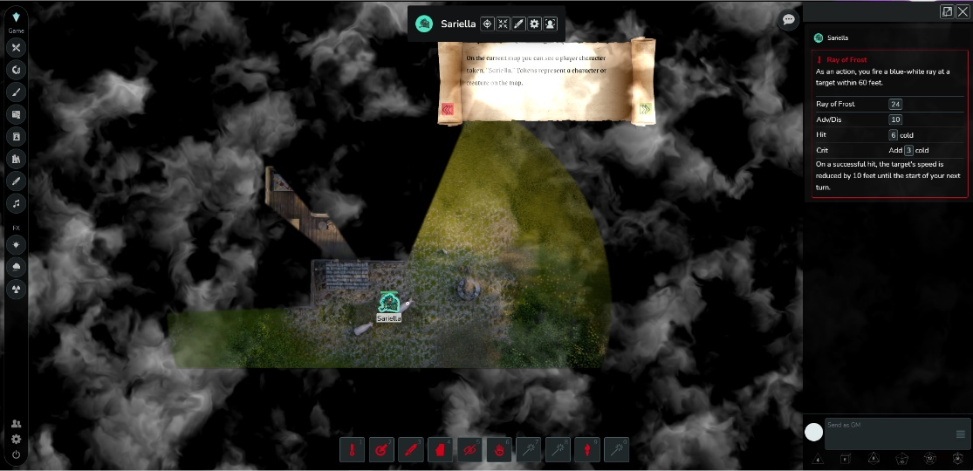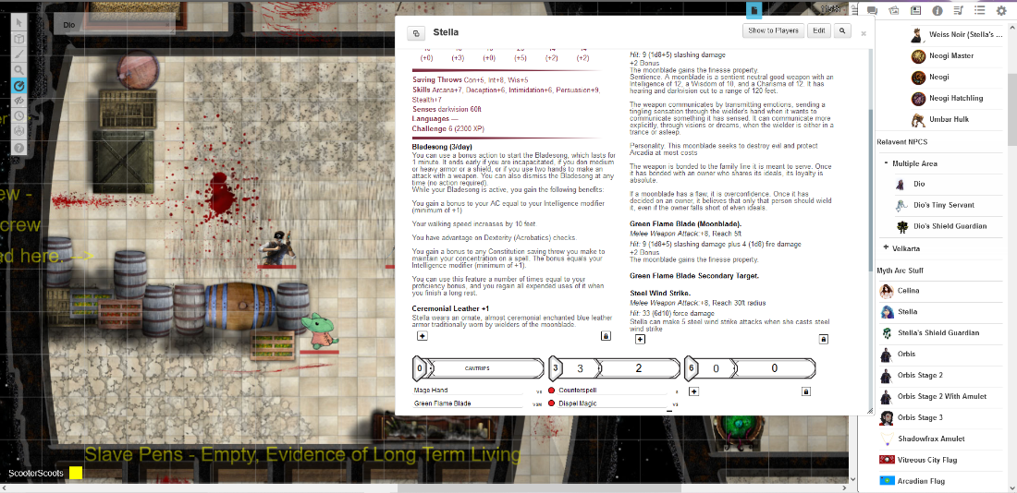A screenshot of Foundry. Included is a character sheet for an NPC, a map of a ship, and a few other things.

A screenshot of Roll20. Note the significantly worse looking character sheet, and lack of a macro bar.

A screenshot of Astral’s Tutorial. The Fog is areas the selected character can’t see.

# Conclusion

Roll20 is outdated, and the time to switch to a better VTT is now. While only three alternatives are outlined in this document, there are several others, such as Talespire and Owlbear Rodeo. Regardless of what you choose, there’s no reason to stick with an aging platform that will probably never significantly improve. For casual and professional users alike.

If you don’t want to spend hours transferring content, Foundry is currently the easiest VTT to switch to. A modder by the name of kakaroto has made a program[3] that can swap your campaign over in minutes (with some caveats). It can be that easy. But regardless of what you choose, a better system is still worth the one-time effort for a lasting benefit.

## Key Takeaways

* Roll20 is aging and should be abandoned.
* Switch to Foundry if you’re a “power user” and / or want an easy switch.
* Switch to Astral if you want a better web VTT. Or buy online hosting for Foundry.
* Switch to Fantasy Grounds if you prioritize automation and integrated content above price and UI quality.

1. Info on Roll20 subscription tiers here: <https://app.roll20.net/why-subscribe-to-roll20>
2. Roll20 Lighting Update: <https://wiki.roll20.net/Updated_Dynamic_Lighting>
3. Roll20 to Foundry campaign exporter: <https://github.com/kakaroto/R20Converter/blob/master/README.md>